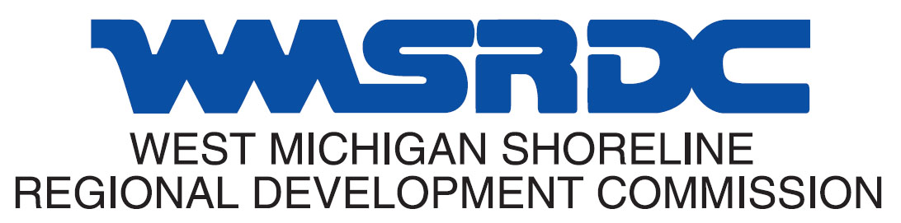

West Michigan Regional Rural Transportation Task Force (Region 14)
Minutes

April 22, 2025

- CALL TO ORDER
Chairperson Timmer called the meeting to order at 9:02 a.m. A quorum was present.

- Attendance
- Members Present
Mark Timmer, Oceana County Road Commission (Chairperson)
Derek Wawsczyk, Newaygo County Road Commission (Vice Chairperson)
Kasey Jernberg, Newaygo County Village/City Representative
Brad Hinken, Newaygo County Agency on Aging
Jim Koens, Muskegon Area Transit System
Lisa Nagel, Oceana County Counsil on Aging
Steve Wessels, Mason County Road Commission
Harold Nickols, Village of Baldwin
Eric Nelson, Mason County Road Commission
Paul Keson, Ludington Mass Transit Authority
Leroy Williams, Lake County Road Commission
Tyler Kent, MDOT Grand Region
Paul Bouman, Muskegon County Road Commission
Howard Perry, Yates Township Dial a Ride

- Members Absent
Jimmy Newkirk, City of Scottville
Jeff Hodges, Village of Pentwater
Geoff Nelson, Village of Ravenna

- Others Present
Blake Wright, MDOT
Brian Stark, MDOT
Michael Valverde, MDOT OPT
Eric Nelson, Mason County Road Commission
- Staff Present
Joel Fitzpatrick, WMSRDC
Lauryn Blake, WMSRDC
Jack Grice, WMSRDC

- PUBLIC COMMENT

No members of the public spoke.

- REVIEW OF MINUTES

Minutes were reviewed from the last meeting. It was mentioned that two LMTA jobs were incorrect. Staff have fixed those in JobNet. It was also noted that Vice Chair Wawsczyk ran the meeting and Timmer was absent. A motion was made and supported to approve the revised minutes. Motion carried. M/S Williams/Wawsczyk

- FY2023 – 2026 Project AMENDMENTS

Lake County
- Old project: FY 2025 – Yates, Floor/Bus Barn (J# 214569) – STBG $59,496, State $14,874, Total $74,370
- New project: FY 2025 – Yates, Washer/Generator (J# 214569) – STBG $59,496, State $14,874, Total $74,370
A motion was made and supported to approve amendments to the FY2023-2026 project list. Motion approved. M/S Wawsczyk/Williams
- FY2026 – 2029 Project changes
Oceana County

FY 2025
- Job# 223879 – Madison – 144th Avenue to 168th Avenue – STBG $776,957, Local $194,240, TEDF-D $218,000, Total $1,189,197. Change in limit.

FY 2027
- Job# 223885 – Oceana Drive – Madison Road to Jefferson Road – STBG $802,000, TEDF-D $124,459, Total $926,459. Change in limit.

A motion was made and supported to approve amendments to the FY2023-2026 project list. Motion approved. M/S Williams/Keson

- all season route update

Comments received from Mason and Muskegon Counties regarding corrections to the All-Season route maps were discussed. A motion was made and supported to approve the changes (attached at the end of these minutes). Motion approved. M/S Bouman/Williams

- UPDATE FROM MDOT

- No update.
- RURAL TRANSPORTATION ROUNDTABLE

- Mr. Brad Hinken mentioned the upcoming public transit study.
- Mr. Howard Perry expressed his thanks to the Lake County Road Commission for assistance.
- Mr. Joel Fitzpatrick informed the task force that road ratings will begin soon.
- Mr. Keson thanked the quick approval of the email amendment request earlier in the month.

- NEW BUSINESS

- Mr. Wawsczyk mentioned that Newaygo County was looking at selling their FY 2026 Fed Aid. A motion was made and supported to approve the sale. Motion approved. M/S Jurnberg/ Wessels

- UNFINISHED BUSINESS

No unfinished business was discussed.

- PUBLIC COMMENT

No members of the public spoke.

- ADJOURNMENT

Meeting adjourned at 1:37 p.m.

